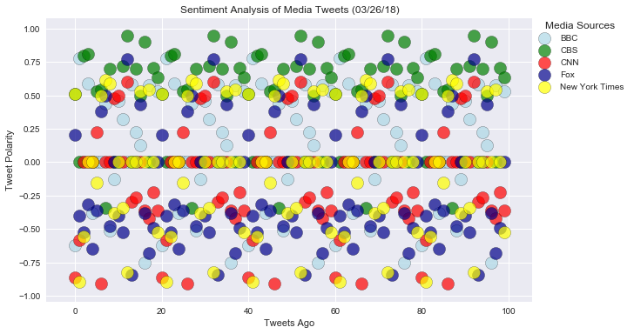

The Sentiment Analysis of Media Tweets chart visualize the sentiments expressed in Tweets sent out by the following news organization: **BBC, CBS, CNN, Fox, and New York times.** Tweets Ago shows the number of recent tweets posted from these news media. Tweet Polarity shows the sentiment of the tweets calculated with Vader Sentiment Analyzer, 1 means extreme positive, -1 means extreme negative, and 0 represents neutral opinion of the tweets. The above chart tells us: the sentiment of most of tweets sent out by these media organization are on the neutral range. Today’s tweets sent out by CBS seem more positive in comparison with the other four medias. On the other hand, tweets sent by Fox sound more negative. The sentiments of the tweets from CNN, CBS and New York Times are mixed, some positive, some negative and more neutral.

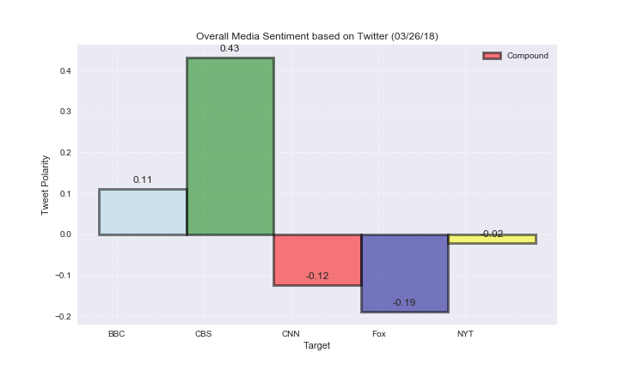

The Overall Media Sentiment chart gives us the whole picture of the media sentiment analysis, which compound of positive, negative and neutral sentiment. Again, this chart proves the observation of the sentiment of these five news organization, which shows tweets from CBS are more positive, and the tweets from FOX more negative.

Throughout analyzing the sentiments of the tweets sent out by media, we can understand the public opinion on current issues, the bias of the news organizations.